**Lab 2**

**3.** 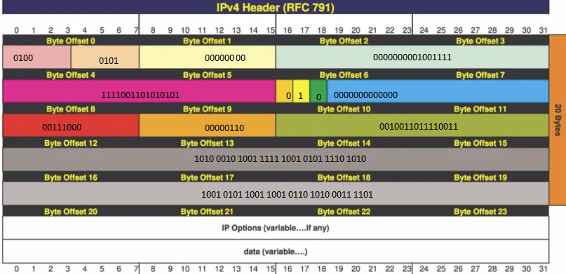

**4.** Explain the fields for a particular IP packet captured. Try to explain the purpose of each

field.

Bytes: 45 00 4f f3 55 40 00 38 06 26 f3 a2 9f 85 ea 95 99 6a 3d

45 – IPv4 + IHL

00 – DSCP + ECN (Differentiated Services Code Point + Explicit Congestion Notification)

00 4f – Total packet length

f3 55 – Unique packet ID

40 00 – Don’t fragment

38 – Time to live

06 – TCP

26 f3 – Error checking header

a2 9f 95 ea – Source IP address

95 99 6a 3d – Destination IP address

**5.** Here you find a network trace with fragment bit set in the IP packets. What’s the major

difference from the packet you described for answering previous questions.

**6.** List three games you like and list their technical/design highlights.

1.) Bloodborne – Bloodborne for it’s time had impressively good cloth physics and blood effects when attacking enemies.

2.) Persona 5 – Persona 5 is a staple of good design. It’s combat is flashy, it’s menus are interesting and its art style is unrivalled.

3.) Sekiro, Shadows Die Twice – Sekiro has an almost flawless parry system as it’s combat’s main mechanic, giving the player a satisfying and skilled fights.

**7.** List the names of applications/services you like (up to 20 names).

1.) Youtube

2.) Steam

3.) Discord

4.)